**Project Management**

**Assignment 1**

**Group Project**

**- Team formation and project initializing –**

**Members:**

Isaac De Hora – g00372043@gmit.ie

Sean Cunningham - g00381530@gmit.ie

Doha Kadour - g00390296@gmit.ie

# **Introduction**

As a group we have limited time to discuss the project fully and its objectives and but I Isaac decided to be the scrum master. The team has been set up and a collective mind map on Mind-Meister so that we can work together at the same time and share ideas.

# **Project Ideas**

* Gamming website
* Bar/Restaurant website
* Cinema website
* Music website
* Clothing website
* Book store

**Group interactive mind map for project objectives and ideas**

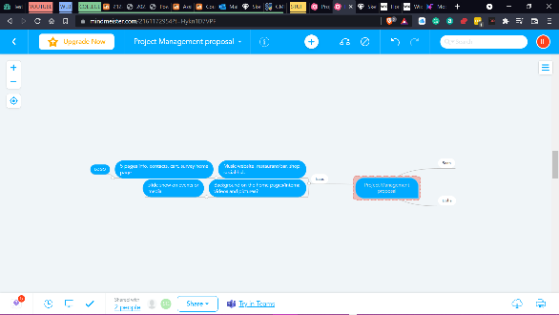

**A made draft of a wireframe/template that could looked at and considered as follows.**

A home page

Content/shop page

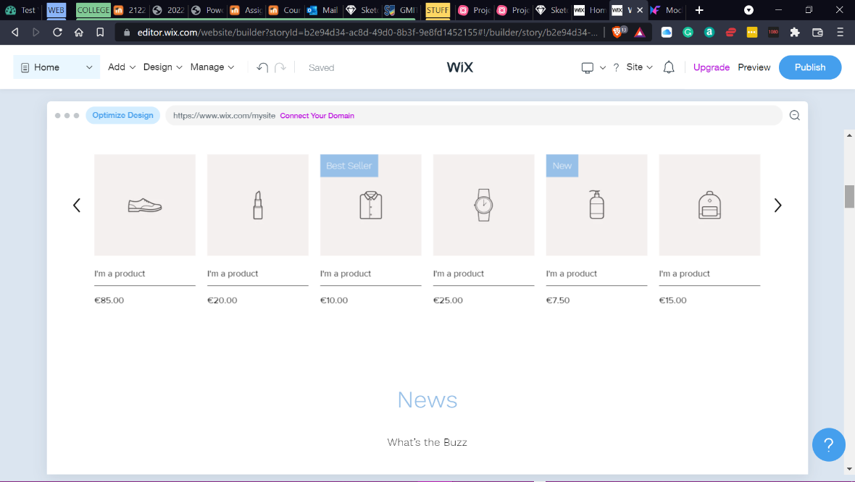

A events/news page

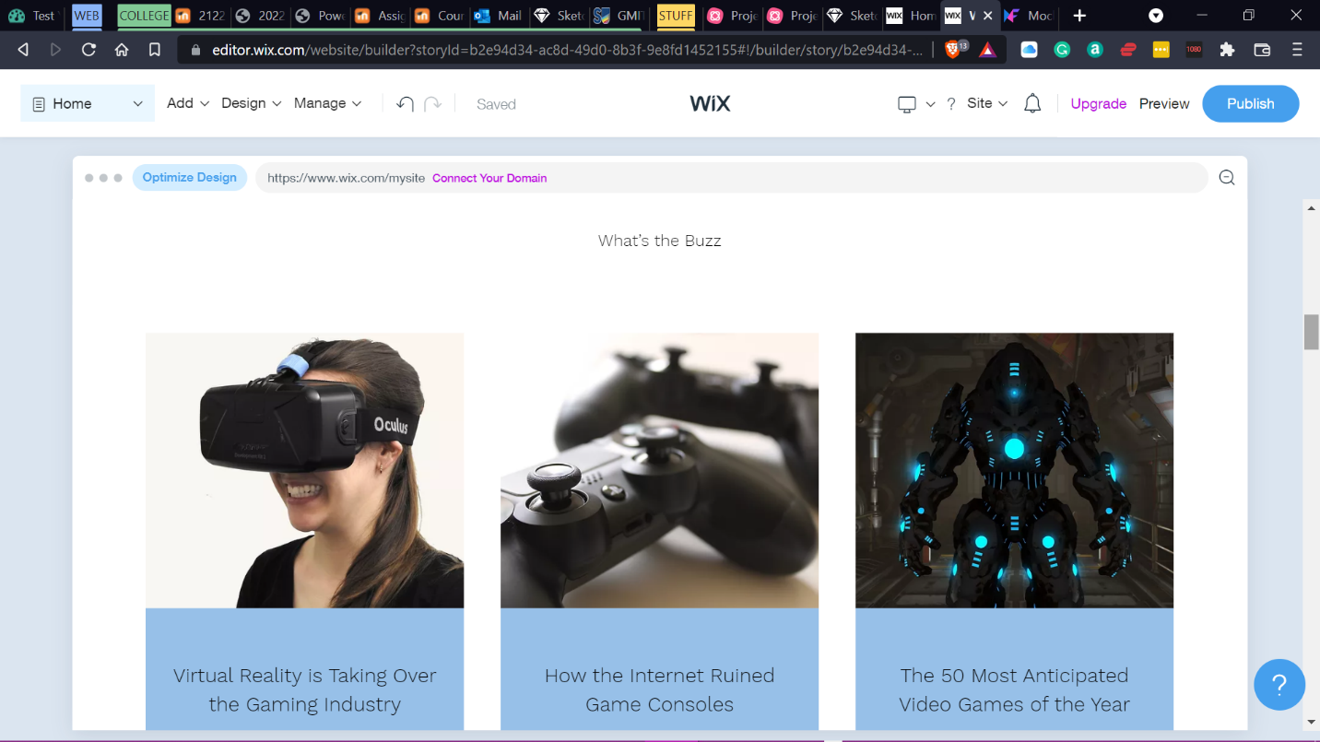

A review page

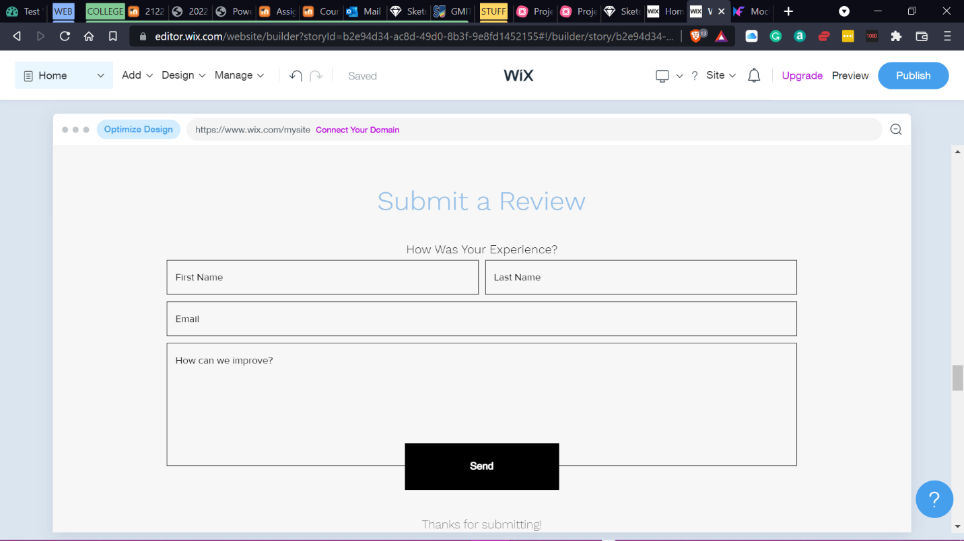

The website to be most accessible would be interactive with all the main devices for accessibility for the users. Maybe an interactive logo could be used for attraction in the aim for users to remember and come back to the product.

**Objectives**

For the website a clean approachable homepage that isn’t too confusing and has the main points the site so that users can find what they came for quickly and easily